**Workshop 1 – Setting up ROS Environment and Understanding of ROS basics**

**Aims and Objectives**

Setting up the workshop working environment by installing ROS to a VirtualBox on your PC and learn ROS basics through the ROS wiki tutorials.

**Exercises:**

As students might have different type of Laptop running on different OS, for simplicity, this workshop will run on Ubuntu Linux installed on a virtual machine – VirtualBox.

1. Visit <https://www.virtualbox.org/> to download and install the latest version or VirtualBox to your PC.
2. There are two ways to install the Ubuntu Linux and ROS to your PC. One way is to download the Ubuntu image from Ubuntu website <https://ubuntu.com/>. You can download the latest desktop version or 18.04 LTS. And then visit <https://www.ros.org/> and follow the wiki to download and install the ROS 1 noetic or melodic yourself, or
3. Download the image I put to the Microsoft team and follow these steps to install the Ubuntu VirtualBox drive which contains the pre-installed ROS 1:
   1. Run VirtualBox and in the oracle VM VirtualBox manager click on the New Icon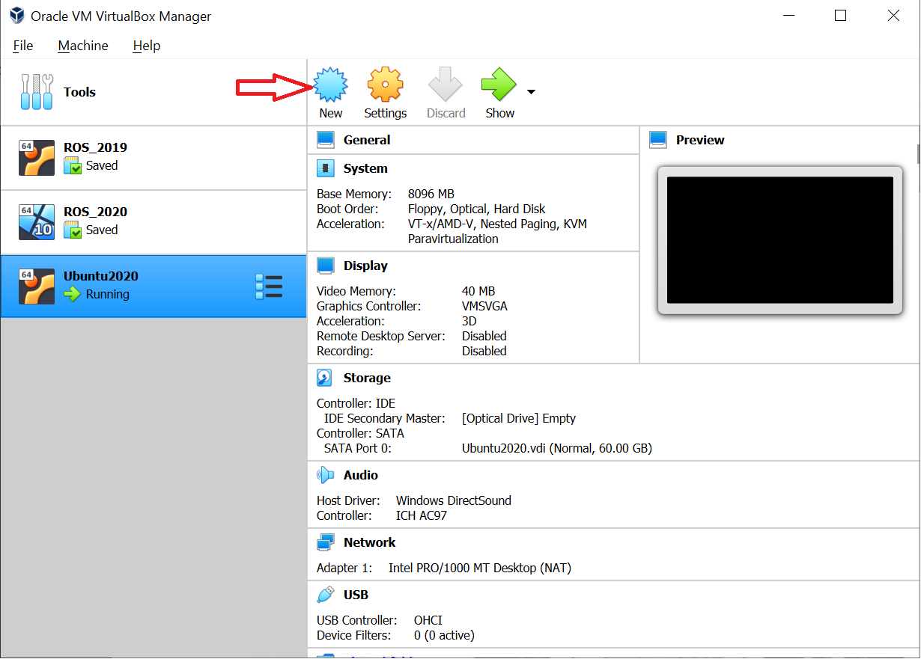
   2. In the create virtual machine dialog, click on Expert Mode button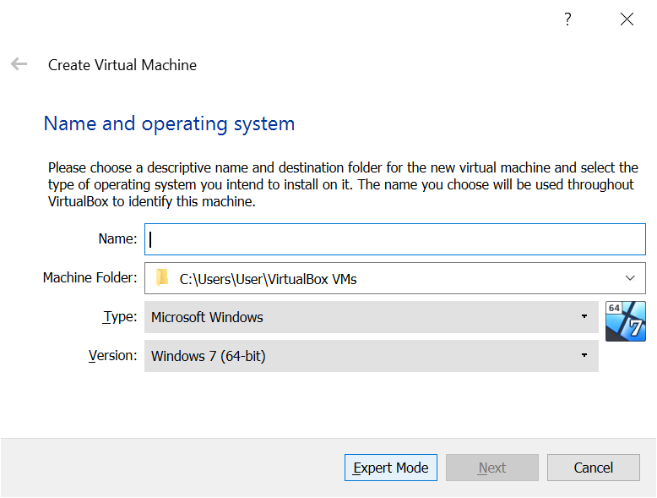
   3. Set the system name, memory size and then click on the Use an existing virtual hard disk file option. The VDI file should be the one you download from the team I provided.

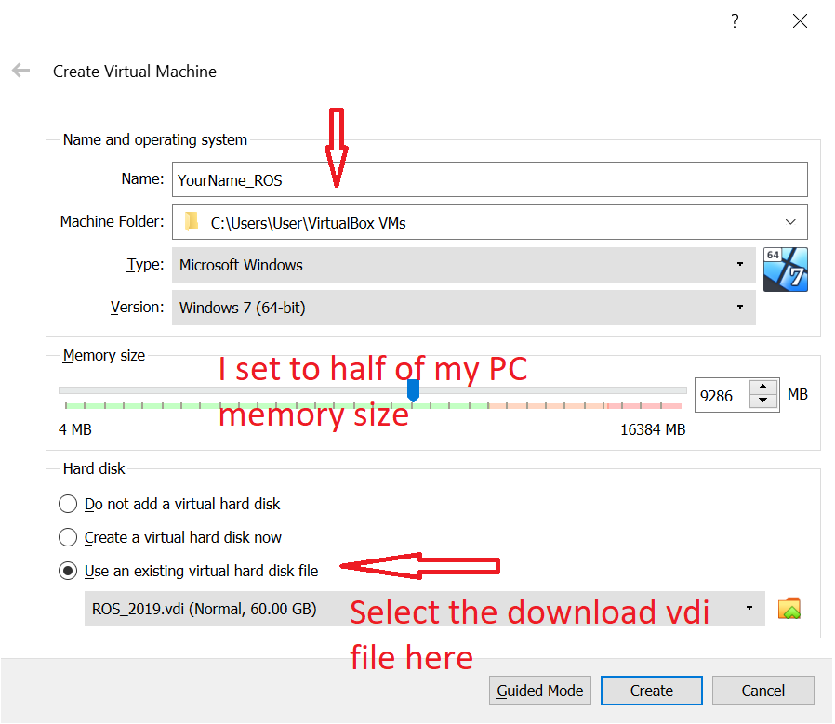

* 1. The password for this ubuntu is “robotics”

1. Login the Ubuntu system and open a terminal, run command
   * Type the following command to edit /etc/hostname using nano text editor:

*sudo nano /etc/hostname*

Delete the old name and setup new name(***The new name should be your last name lowercase)***.

* + Next Edit the /etc/hosts file:

*sudo nano /etc/hosts*

Replace any occurrence of the existing computer name with your new one (***The new name should be your last name lowercase)***.

* + Reboot the system to changes take effect:

*sudo reboot*

1. Up to this step, you have had a working environment for this module. Please visit <http://wiki.ros.org/ROS/Tutorials>. The exercises of this week are to go through beginner level tutorials step by step. When you go through these steps, please record all the ROS output from terminals or ROS simulation windows to your logbook and comments on your observations.